Data analysis and results

# Environmental and Experiment’s conditions

Some of the most important measurements of the experiment were the pressure (P), temperature (T), and humidity (H) determination inside and outside the experiment. These variables are measured inside the Sensorbox (using the index “in”), and outside the Sensorbox while inside the Ecobox (using the index “out”). The environmental conditions (using the index “env”) were not measured by the experiment’s components, but they are provided by the BEXUS gondola.

In the following paragraphs these measurements, alongside others relevant to temperature, will be presented.

## Ascending

### Live analysis and comparison

In this subchapter the graphs that were live demonstrated are presented, hence the data are not cleaned yet. Also they are being compared to some data provided by the BEXUS organizers.

The variables Tout and Pout as functions of the gondola’s altitude are given in the below graph, regarding the ascending phase.

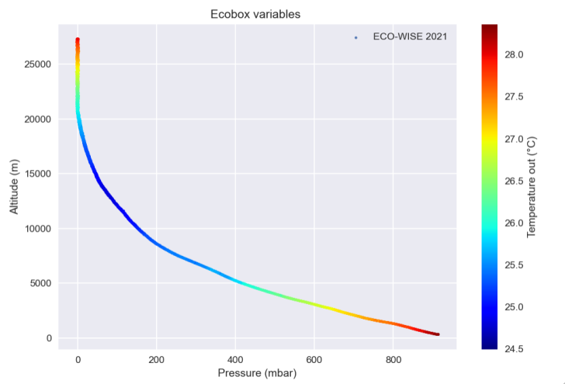

Graph 1: Ecobox variables (P, T)

The extreme values of Tout were [24.5 oC, 28.5 oC]. In comparison with the ambient temperature, these are extremely high, even without being inside the Sensorbox. In the “Thermal” segment of the SED further explanation is provided.

For higher altitudes than 20 km, the curve is flattened because the pressure sensor was not capable of measuring under a certain threshold. This will be discussed in detail later.

The ascending phase ended at 27.3 km, and it was linear. The mean gondola’s velocity was about 3.7 m/sec, according to the ECO-WISE measurements.

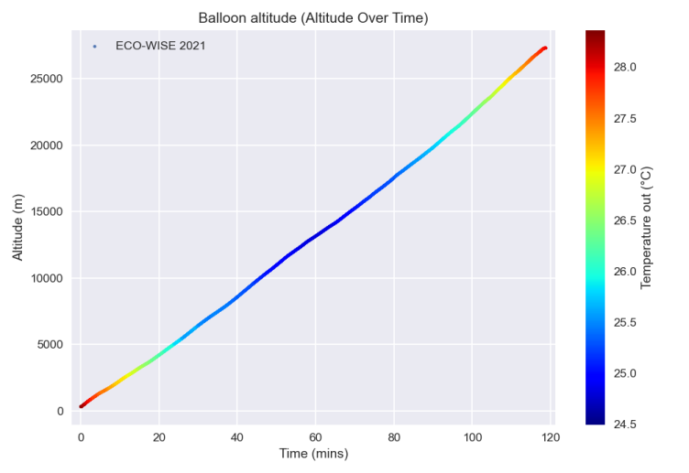

Graph 2: Balloon altitude over time

The sensor’s and the pump’s temperatures were also very high in comparison with the ambient. We observe similar behavior during this phase. These components also contributed to the thermal preservation of the whole experiment.

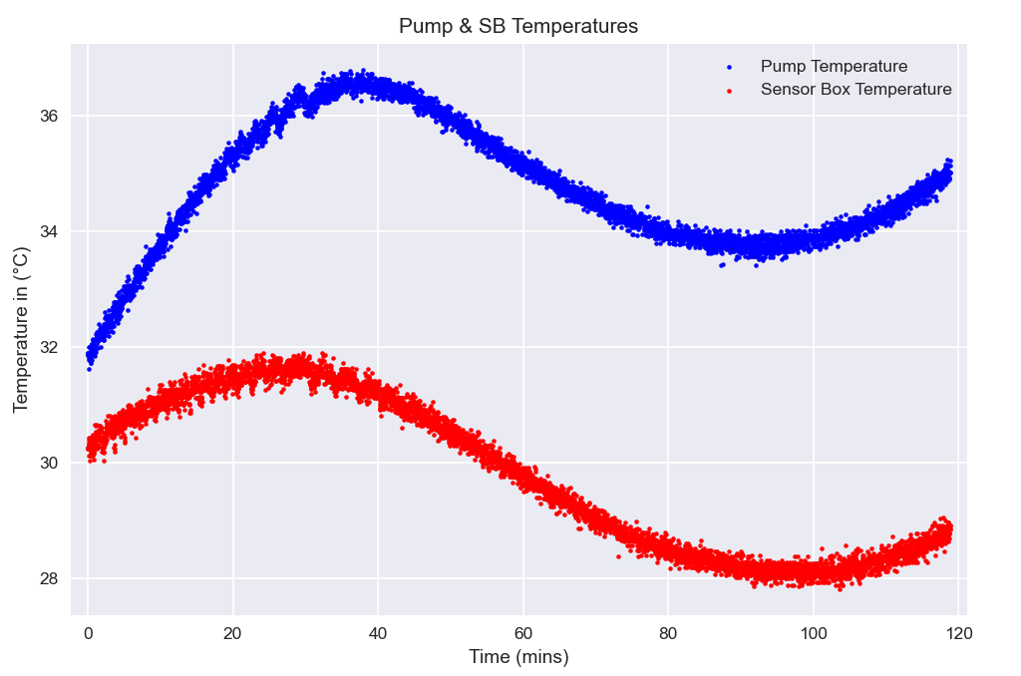

Graph 3: Pump and sensor temperature

Humidity inside and outside the sensorbox throughout the ascending phase was within the specified performance requirements. The extreme values of the outside Humidity were measured to be 1.03% and 19.79%. Humidity inside the box was measured to be greater than outside at every stage but also steadily declining while the balloon was ascending, with its extreme values being ranging from 4.35 % to 26.2 %. The periodic fluctuation in humidity due to the pump’s function can clearly be seen in the graph.

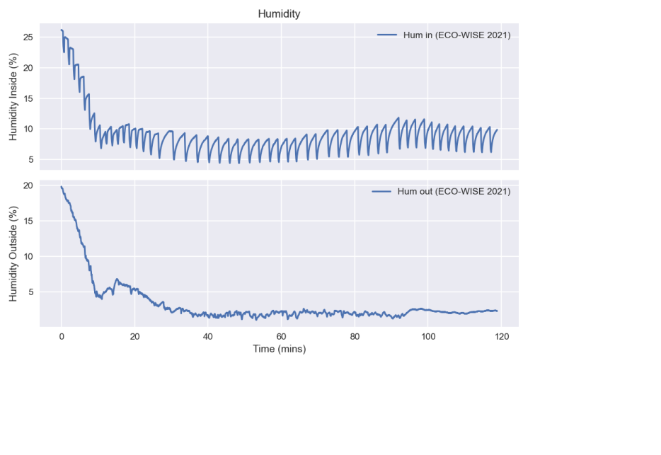

Graph 4: Humidity measures inside and outside of the sensorbox

However, when comparing the measurements for outside Relative Humidity from [BEXUS] and [ECOWISE] there is an obvious significant deviation.

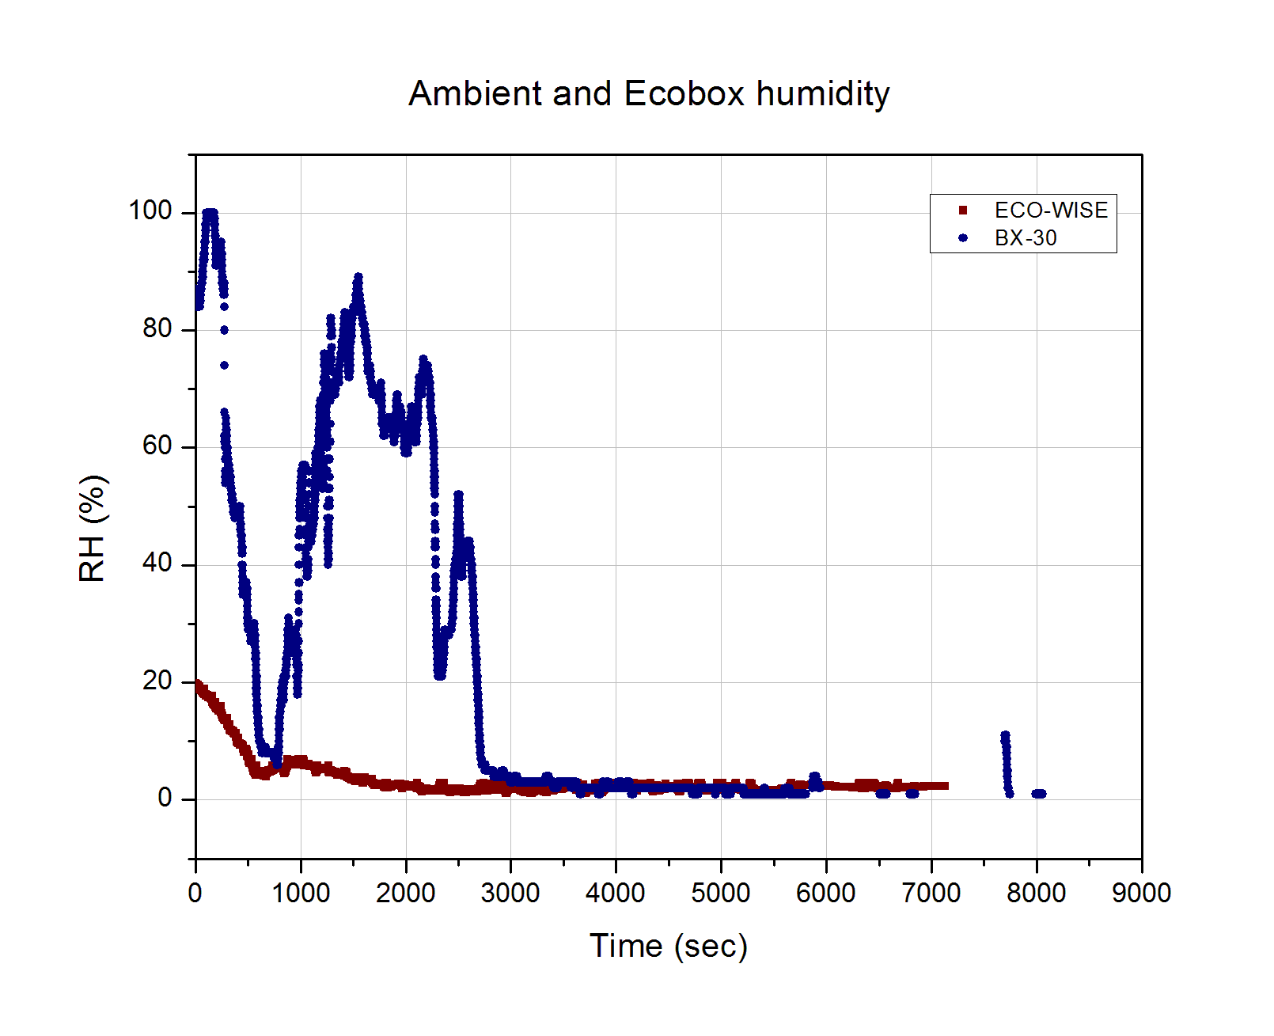

Graph 5: Relative Humidity (ambient and outside) as a function of time

This deviation can be explained by considering the difference in outside temperature measured. As can be seen below, the ambient temperature measured by the ECOWISE sensors remained practically stable whereas the actual ambient temperature, as was expected, steadily declines, and reaches a plateau at greater altitudes. Thus, taking into account the inverse proportionality between temperature and relative humidity, the differences in measured RH can be safely attributed to the temperature difference.

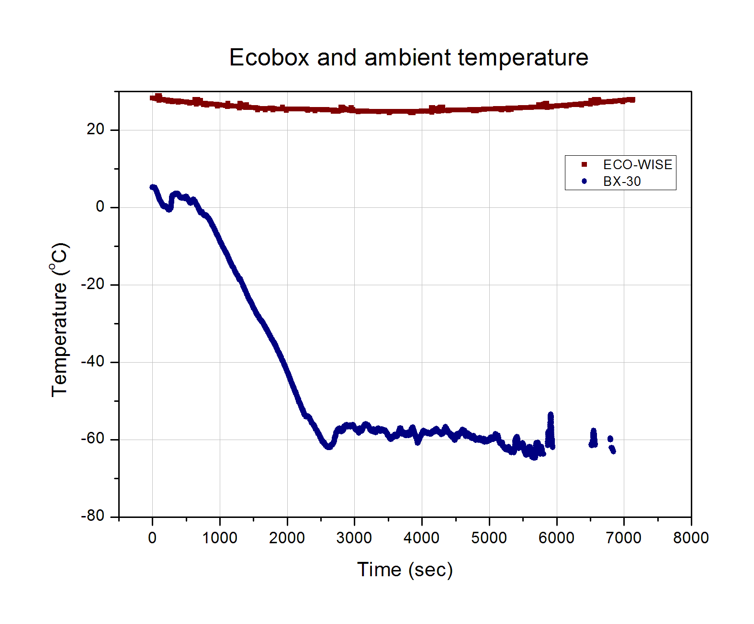

Graph 6: Ambient and outside temperature as a function of time

The temperature and pressure inside the sensorbox as a function of time during the ascending phase are presented below.

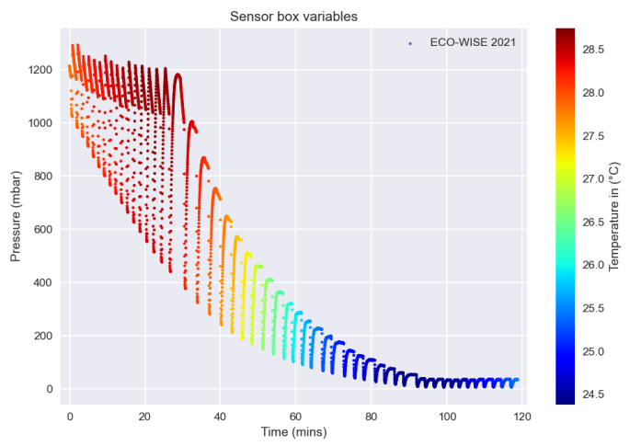

Graph 7: Sensorbox Variables (Ascending phase)

The inside temperature remained well within the specified range of [-40 oC, 60 oC ] throughout the ascending phase. In fact, it remained surprisingly stable between 24 oC and 29 oC, which is further discussed in the “Thermal” segment. The temperature’s stability can be seen well in the graph below.

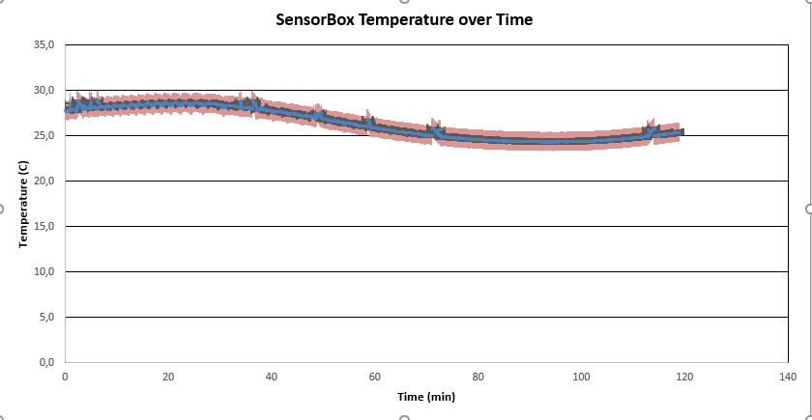

Graph 8: The temperature inside the sensorbox remains remarkably stable throughout the experiment

Conversely, the pressure inside the sensorbox did not meet the performance requirements during the ascending phase (pressurization up to at least 800mbar at every cycle). The repeated cane shaped curves seen above represent each cycle. The pressure starts off equal to the ambient pressure and the pump steadily pressurizes the air in the chamber. Afterwards, it remains constant for a short time frame, when measurements are taken, and then quickly drops back to the atmospheric pressure while all the valves are open. As is evident in the graph above, the pump was not able to continuously raise the pressure sufficiently after the ambient pressure was lower than 280 mbar. Unfortunately, it was determined that there was a leak somewhere in the sensorbox which resulted in the pressure inside essentially matching the atmospheric pressure during almost every stage. It should be noted that the selected pump could have perhaps not been perfectly suited for the required pressurization. This is being examined in detail in a following chapter. The measured extreme values were [6.5 mbar, 1290.9 mbar].

The ambient pressure and temperature, as well as the altitude of the experiment over time were also measured by independent sensors, and the data are provided by the BEXUS organizers.

In the following graph, the pressure measurements over altitude are presented. The pressure inside the sensorbox follows the periodic behavior mentioned above, with its minimums being inside the accepted error area of Pout for the higher altitudes. This was expected by the construction of the experiment’s stages, since all the valves are open during stage 3. Thus, Pin should equal Penv, or the ambient pressure. The ecobox was not airtight, so the ambient pressure should equal Pout, as an isothermal atmosphere implies.

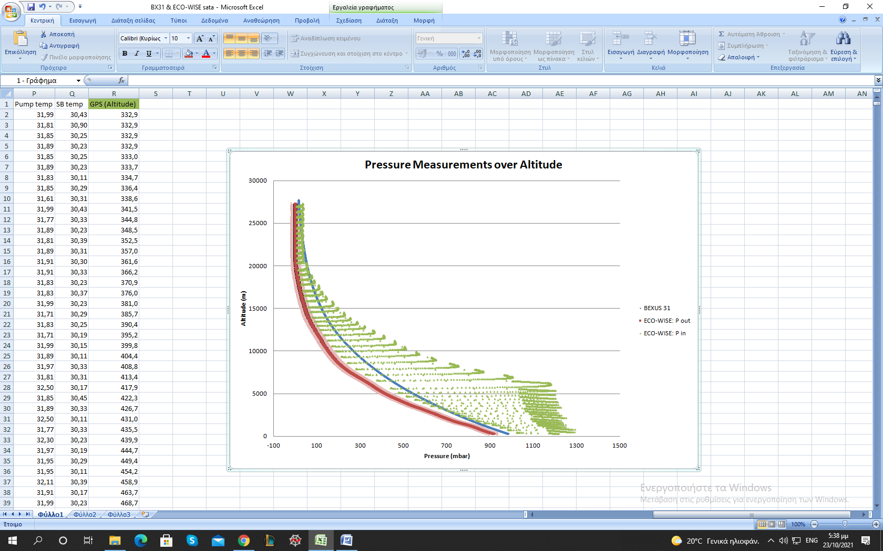

Graph 9: Pressure measurements

As the altitude decreases, the abovementioned equivalence between Pin and Pout disappears. Taking the pump’s behavior into account, this could be explained by its power, since the pump was providing a high flow rate which could not be compensated by the decompression in the given time period of stage 3. Namely, if the pump’s flow rate is quantified by a function “f”, then it is a function of both Penv and (Penv – Pin). Considering that Pin increases over time, during stage 1, it stands to reason that “f” is also a function of time. Therefore, for higher values of Penv, “f” gives higher flow rate and thus more time, than the duration of stage 3, is required for (Penv - Pin) to equal zero.

This graph also shows the ambient pressure measured by the independent sensors. There is a significant systematic deviation between the two sensor’s measurements. A possible explanation is that the two sensors used were strongly affected by the temperature difference, which was up to 90 oC.

### Post analysis

Although all the aforementioned explanations are consistent, it can be seen that the systematic deviation between the two sensor’s measurements regarding the ambient pressure is not constant. It should be reminded that in the above subchapter there has not been any data cleaning. On the contrary, in this subchapter the analysis presented is more detailed and consistent with the exponential atmospheric law.

In addition to the Balloon’s altitude measurements by the experiment’s GPS, the following graph presents the independent altitude data.

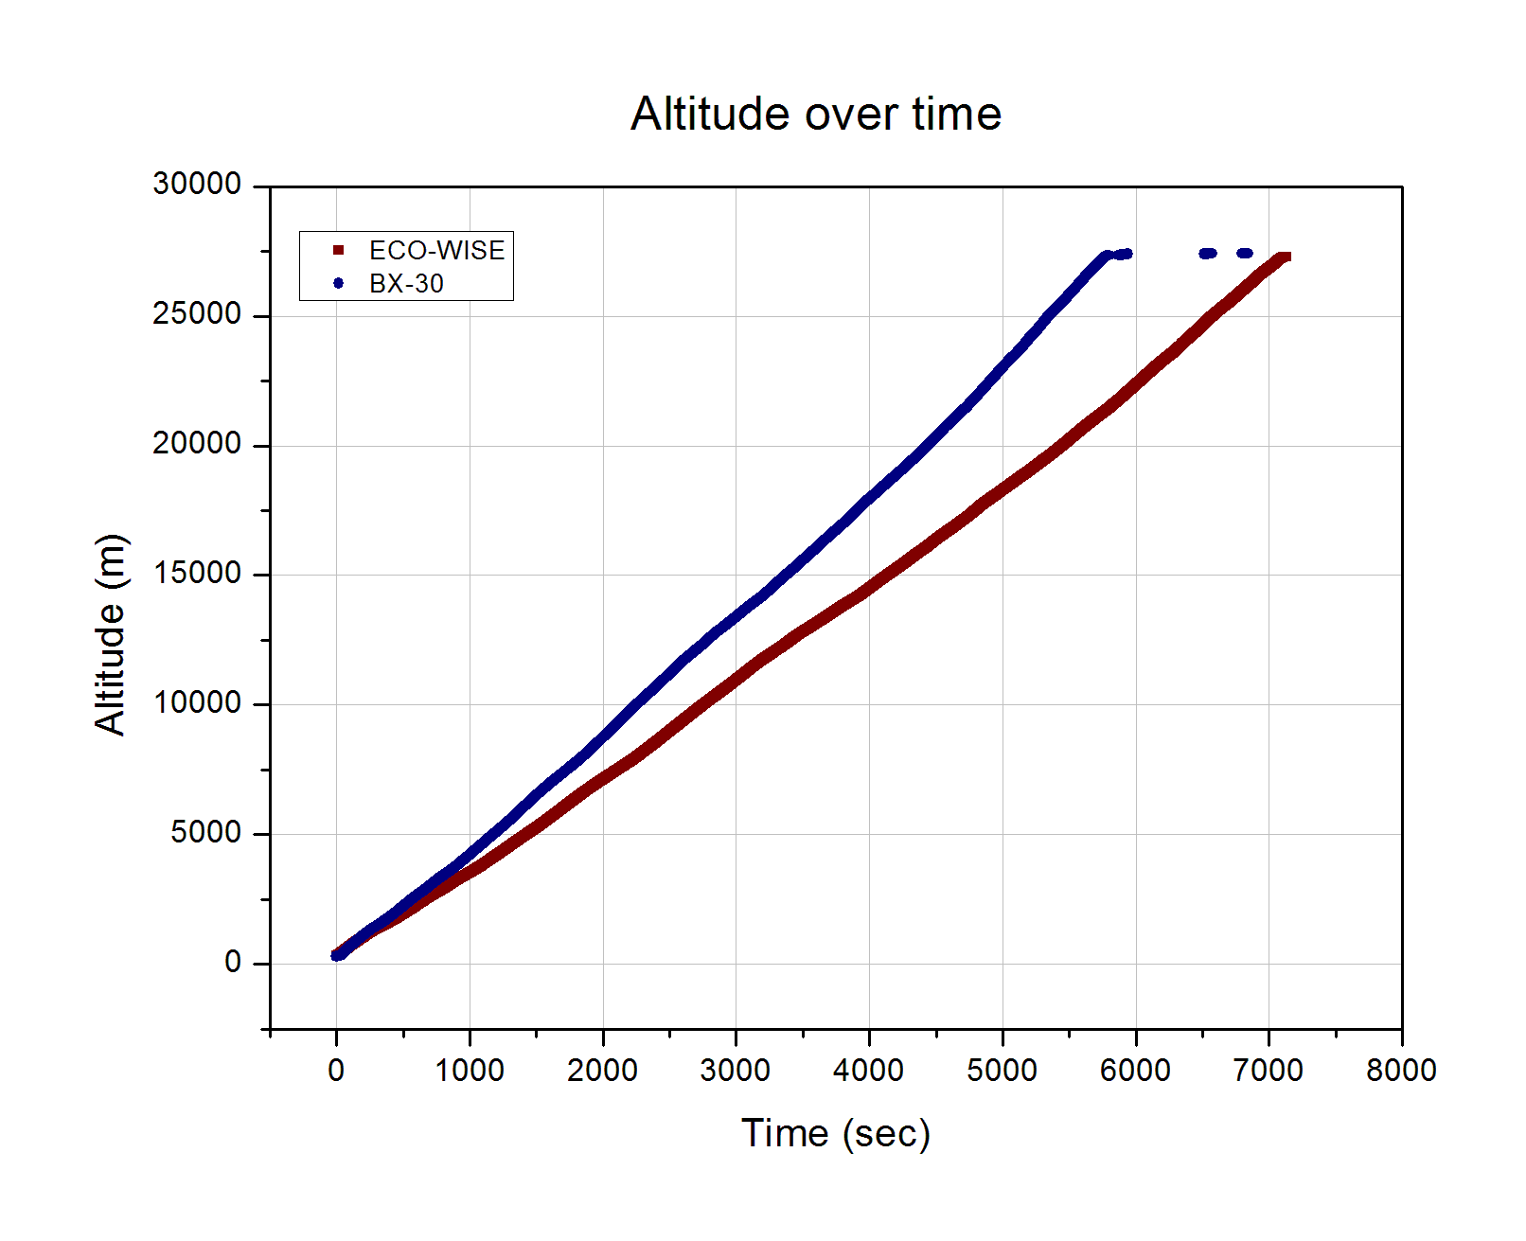

Graph 11: Altitude measurements during ascending phase

During the ascending phase the ECO-WISE team observed a significant delay in the altitude measurements compared to other teams. It can be concluded that the GPS did not function properly. Both curves are almost linear with different slopes, which indicate different vertical velocities. The observation made during the BEXUS campaign is being confirmed by this graph. Thus, the BEXUS altitude measurements will replace the ECO-WISE measurements with respect to the time. This action will be tested by its results on the pressure – altitude relation.

The corrected altitude over time graph is presented below. The curve is still linear during the ascending phase and the mean vertical velocity is 4.7 m/s.

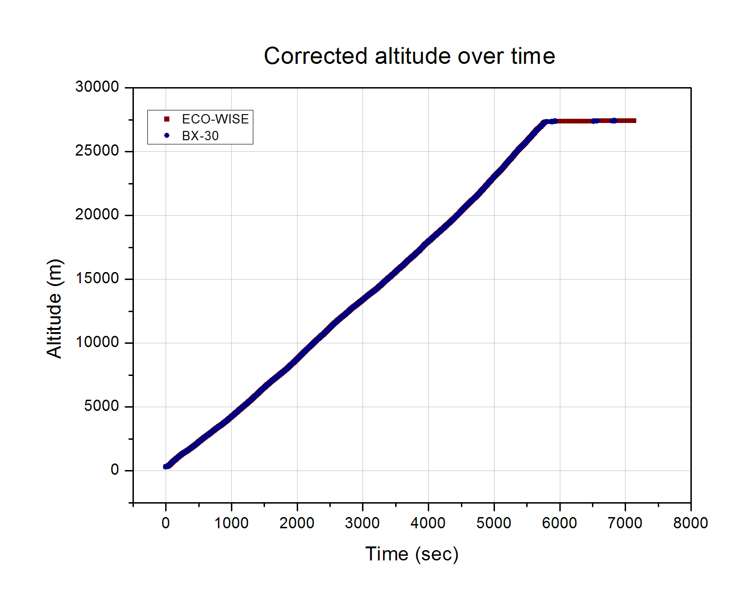

Graph 12: Corrected altitude over time

The critical test for this action is comparing the new pressure – altitude curves.

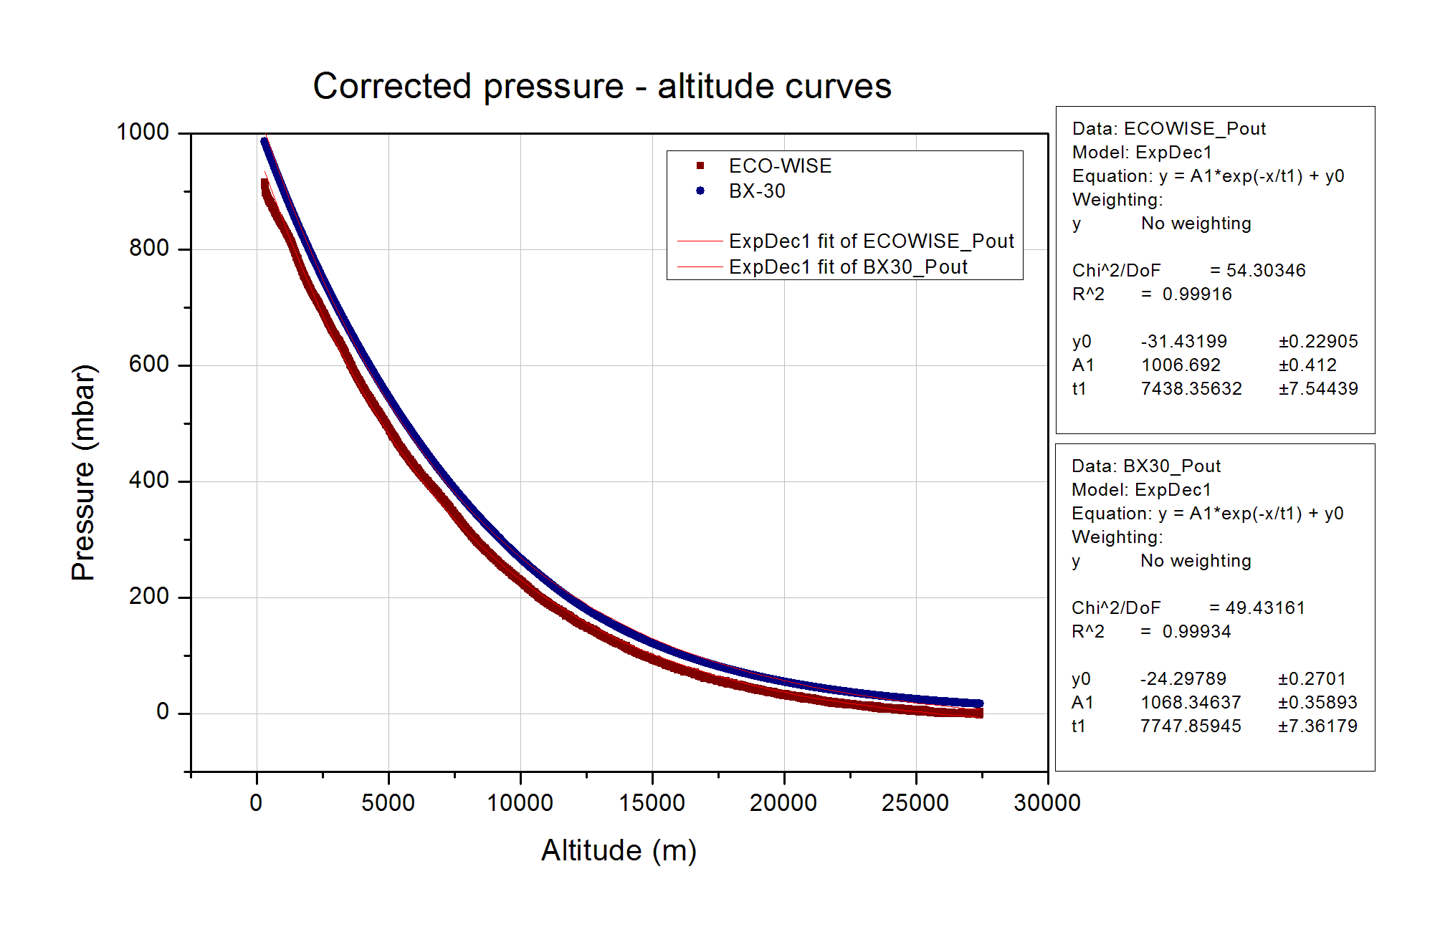

Graph 13: Corrected pressure – altitude graph without error bars

The isothermal atmospheric model suggests that:

where h0 is the isothermal scale height of the atmosphere:

and:

* T : the average temperature
* R : the ideal gas constant
* m : the mean molecular weight of air
* g : gravity acceleration

From the above exponential regression fittings, it can be derived:

The percentage deviation is 3.99 % and can be attributed either to the different sensors, or to the different conditions in their environment. Considering that the mean molecular weight of the air is related to the humidity, and that the humidity difference between the two environments was significant as shown in the previous subchapter, this difference can be partially explained. For the purpose of this experiment, this deviation is acceptable. Taking into account the pressure sensor’s error bars, it is clear that the deviation is negligible for a wide altitude range. Thus, the test is passed and the analysis will be based on this data combination.

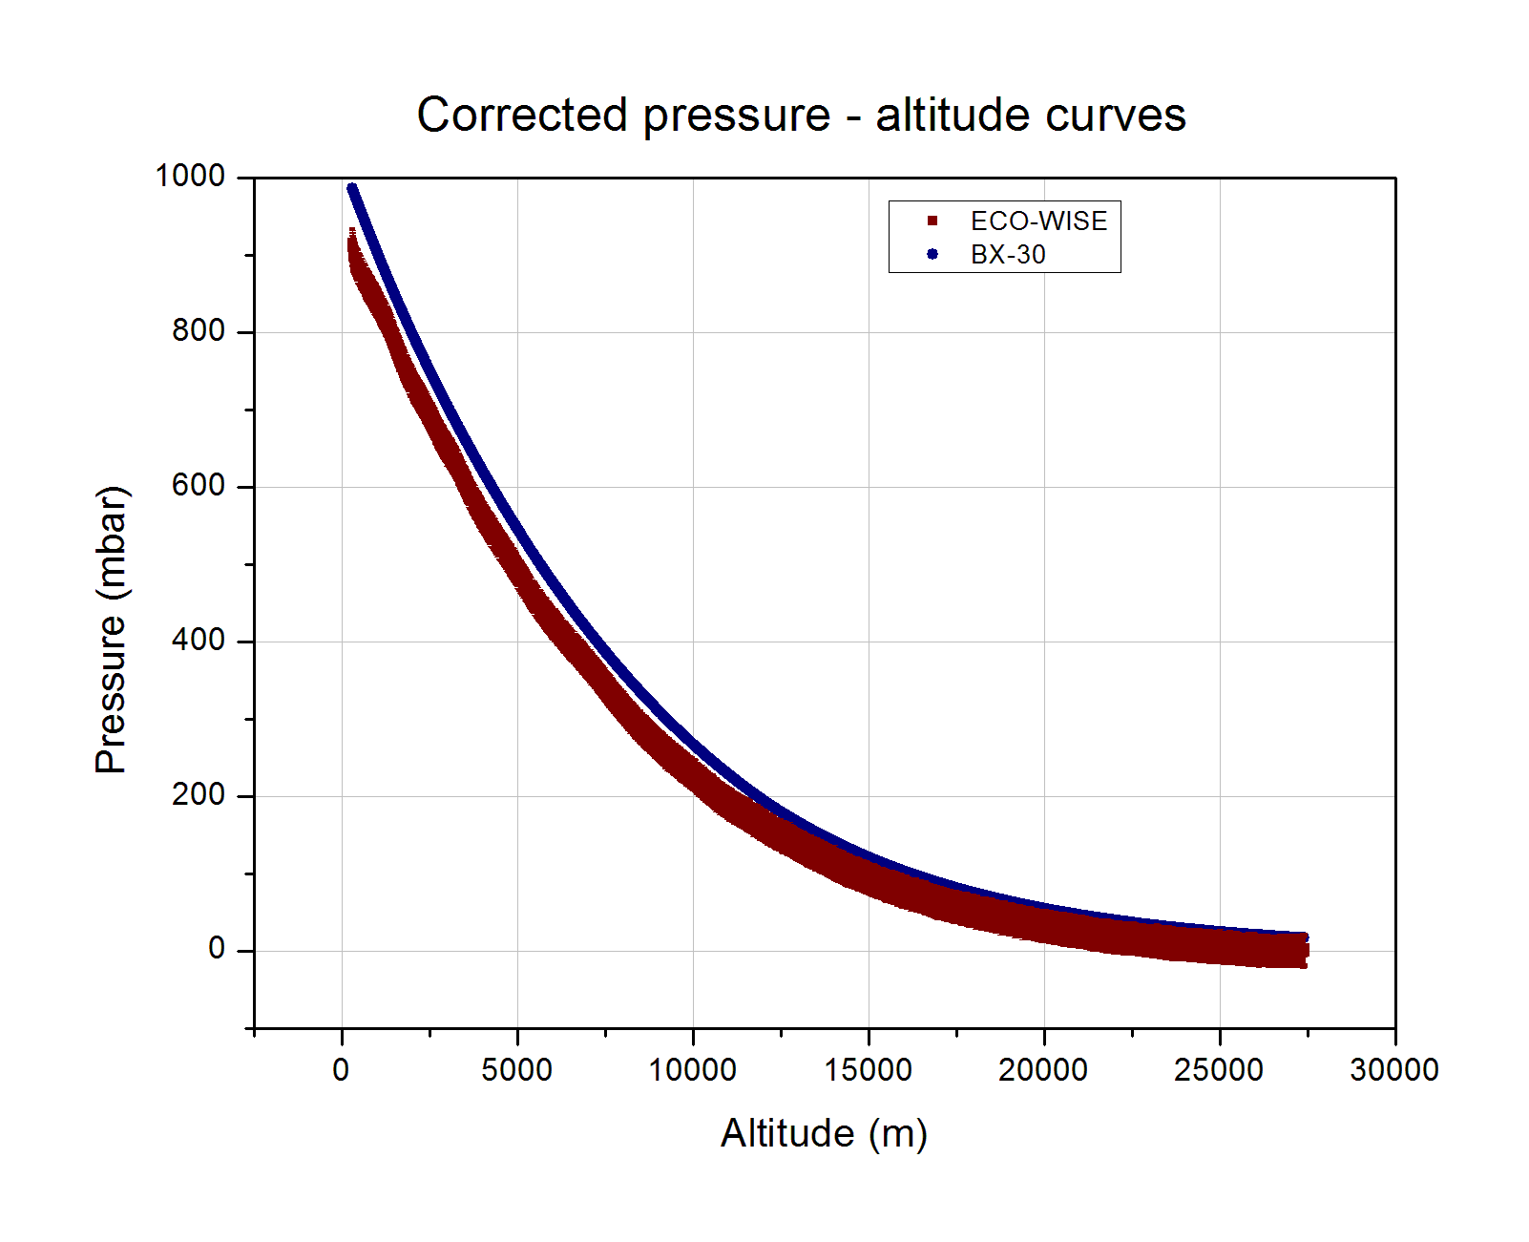

Graph 14: Corrected pressure – altitude graph with error bars

In the following graph, the pressure inside the Sensor-box is added to the pressure graph. The explanation given in the previous chapter about the incompatibility between the minimum pressure values inside the Sensor-box and the ambient pressure is still consistent. The differences are now even smaller, which implies again that the data matching was correct.

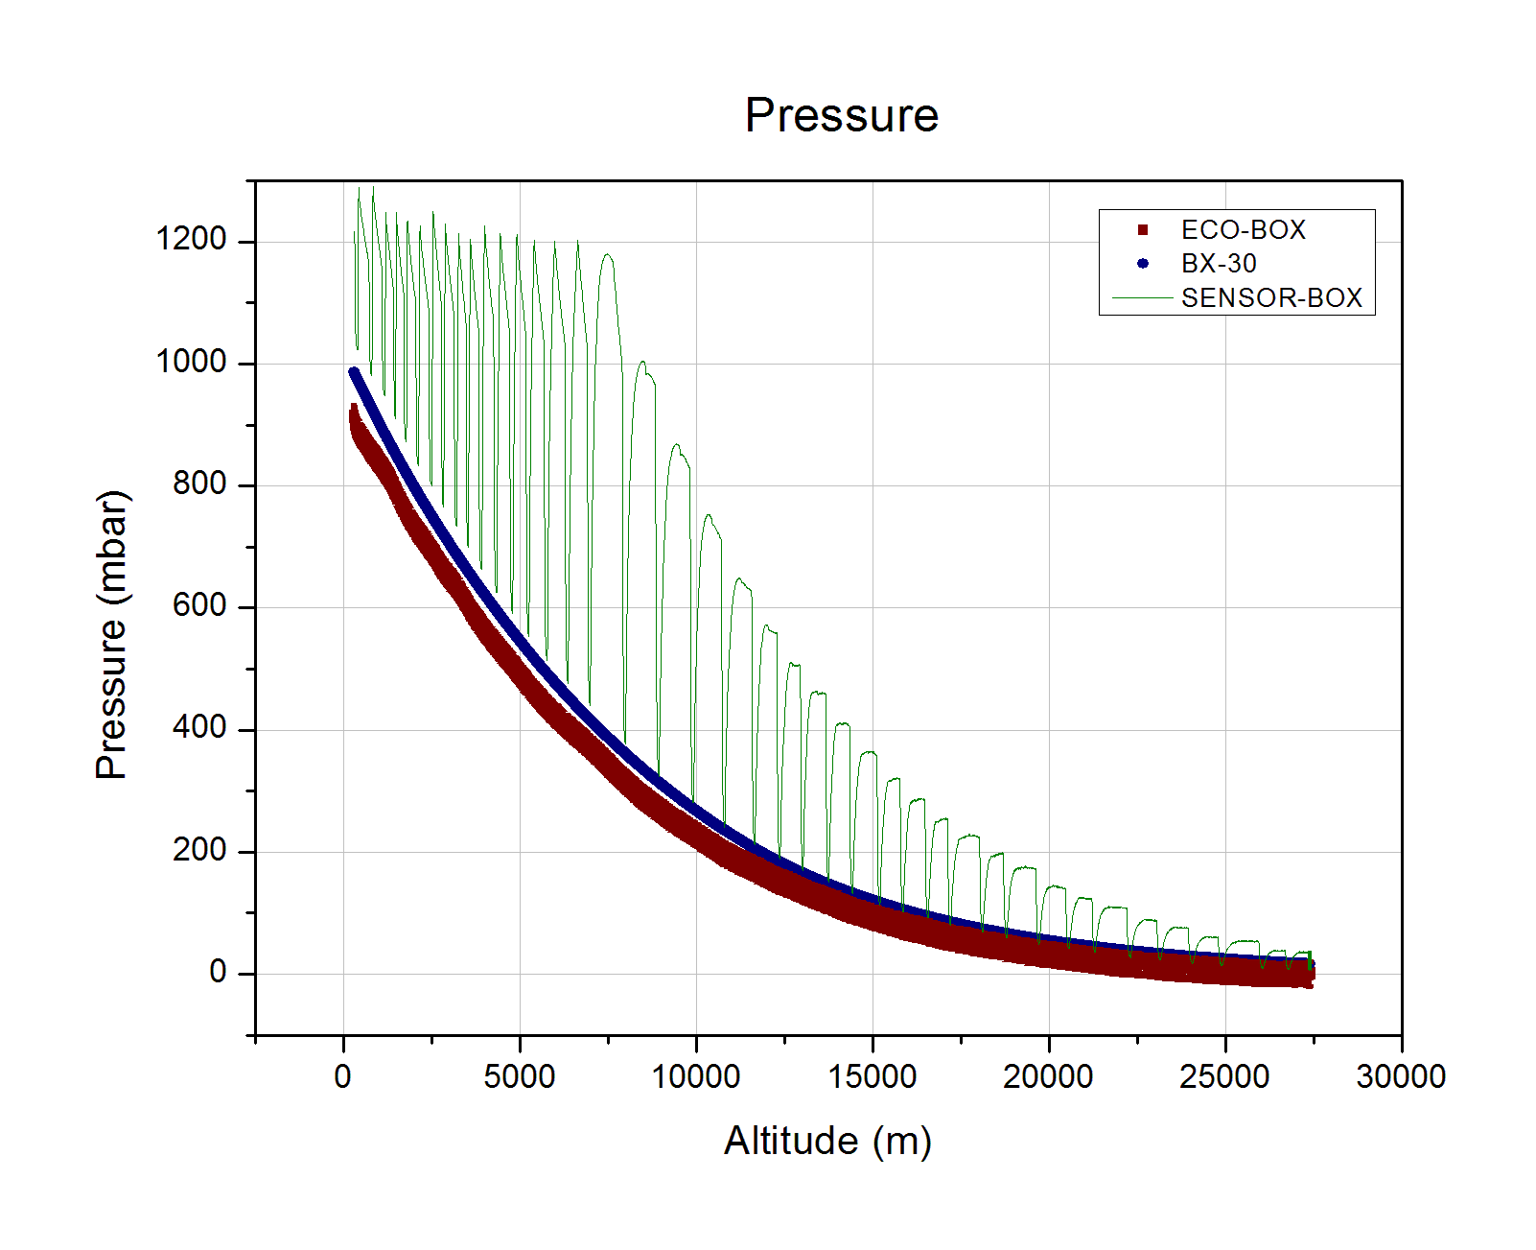

Graph 15: Pressure graph

## Floating

During this phase there is no need of doing the same process since the altitude is almost constant and it does not provide any important information.

During the floating phase the pressure was extremely low and therefore the pressure sensor was not reliable. There are even negative outputs.

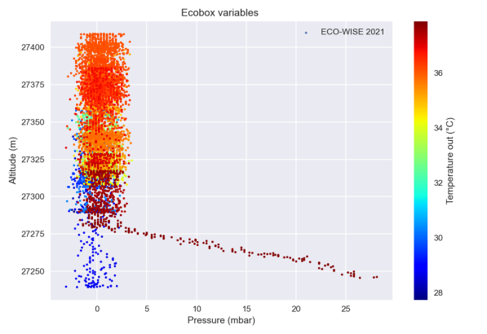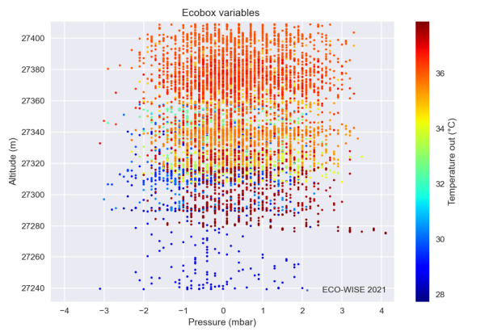

Graph 16: Ambient pressure during floating phase

In these altitudes we expect the pressure to be less than 20 mbar. Since the error of the sensor is ±20 mbar in the temperature range [0 oC, +40 oC], the pressure measurements are not valid during this phase.

The fluctuations in the altitude during the floating phase are presented in the following graph. In this phase the connection was lost for some minutes and this is the reason of the first wide gap in the data. The other discontinuities are attributed to the restarting of the experiment in order to change the maximum value of Pin, since the pump was not capable of reaching the initial pressure target.

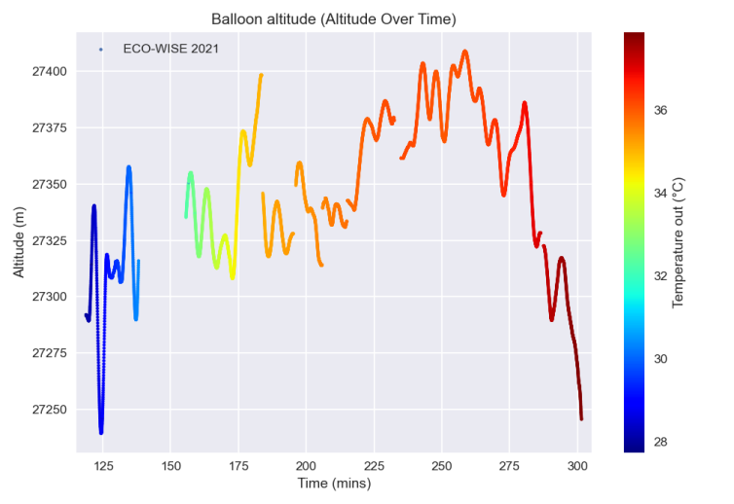

Graph 17: Altitude and temperature over time

The component’s temperature in the floating phase increased and this is again discussed in the “Thermal” segment.

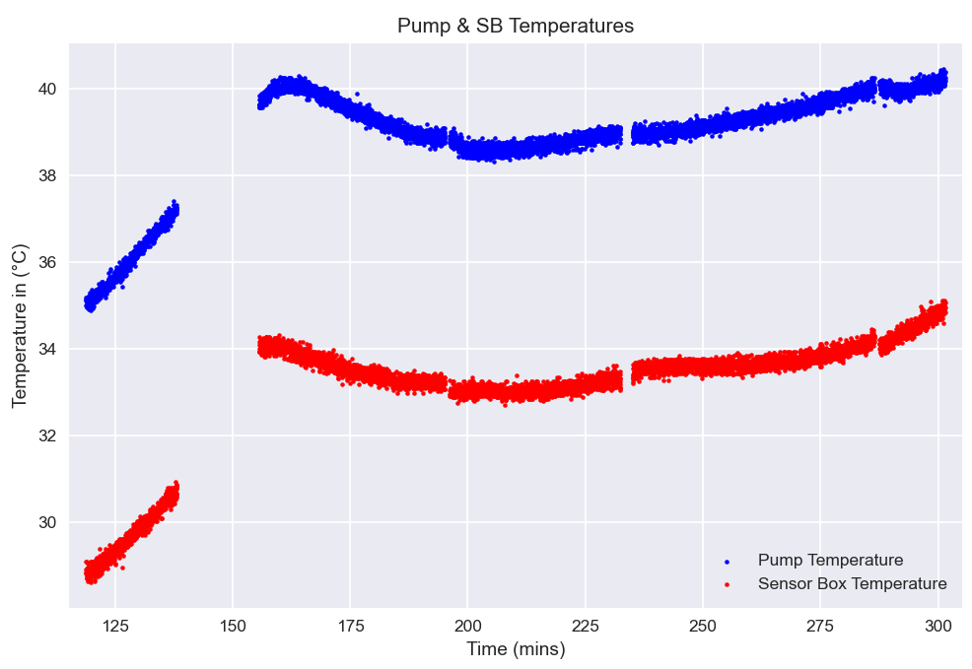

Graph : Pump and component’s temperature

As mentioned above, there exist certain discontinuities in the graphs below which are attributed to a loss of signal as well as the resbooting of the experiment’s systems.

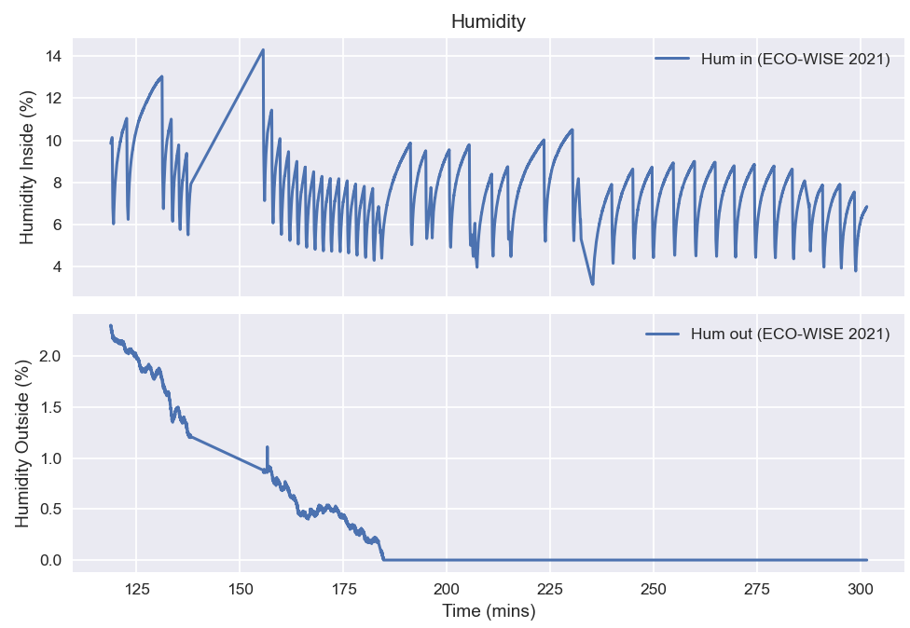

Graph 19: Humidity inside and outside of the sensorbox during the floating phase

The outside humidiity remained relatively stable throughout the floating phase and any changes were mostly gradual with its values ranging from 0 % to 2.3%. The humidity measured inside however, as can clearly be seen in the graph, varied greatly and changed periodically with every cycle, with its extrema values being [3.17 %, 14.29 %].

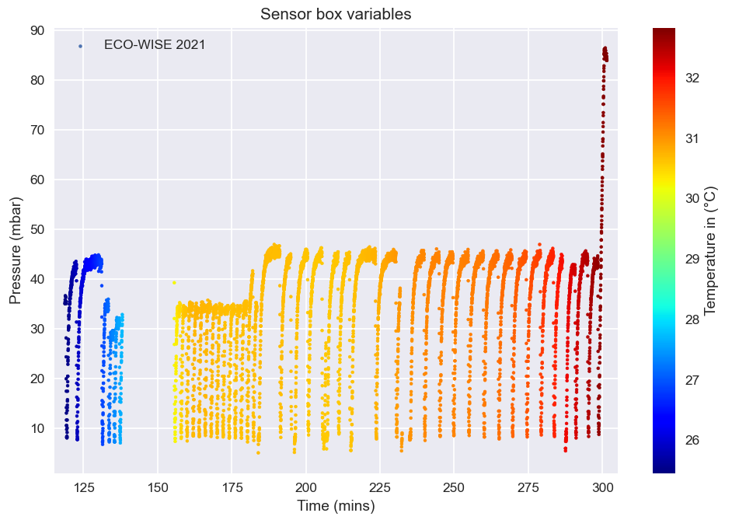

Graph 20: Sensorbox variables during the floating phase

Again, the temperature inside the sensorbox remained relatively stable and slightly higher during the floating phase, in the range [25.5 oC, 32.5 oC]. The inside pressure remained extremely low, and the pump could only raise its value up to 47 mbar with the minimum pressure being 5 mbar.

## Sources

Isothermal atmosphere:

<https://farside.ph.utexas.edu/teaching/sm1/lectures/node55.html>

# Pump’s flow-rate modeling

From the Pin data (pressure inside the sensorbox), the pump’s flow-rate can be modeled. This process is being theoretically analyzed in the chapter 4.1.2 “Calculating pump’s flow-rate”. In the next chapters this method will be implemented on the real data gathered during the flight.

## Simplifications

For a first order analysis, some simplifications are important. The formula derived from the theoretical analysis is:

Since the duration of the pressurization, which is stage 1, is maximum 2 minutes, Tout and Pout will be considered constant values. The quantity Vin is always constant and according to the data, Tin is also a constant with significant accuracy. Therefore, the flow-rate can be expressed as:

The constant am will vary with the different cycles of the experiment. So in the cycle m, am will be expressed as:

The units will be: Vin [lit], T [K], P [mbar].

Thus, for every cycle, am and Pin derivative have to be calculated. There is no interest in calculating am so the analysis will be focused on the derivative of Pin.

One last important simplification is that the leakage is not taken into account.

## Sensorbox pressure profile

During stage 1, the air is pressurized in the sensorbox and thus the rate of change of Pin is very important for modeling the pump’s behavior.

Among different functions, the one describing the data more efficiently is:

The number of cycles that has been selected to focus on is thirty-two. For the first 20 minutes of the flight the pump was capable of providing almost constant flow-rate, or equivalently the pressure was linear, since the duration of each cycle was such that the function Pin could be approximated as linear. Also, for the last cycles of the ascending phase the pressure sensor was not reliable enough. Thus, the sample cycles selected for the pump modeling are between the first 20 and 100 minutes of the flight.

The altitude and the ambient pressure at the beginning of the corresponding cycle are described as initial conditions. The initial conditions of the sample cycles are between 5 – 27 km and 450 – ~1 mbar.

The following graph shows the pressure changing with each cycle’s duration, regarding the pressurization stage only.

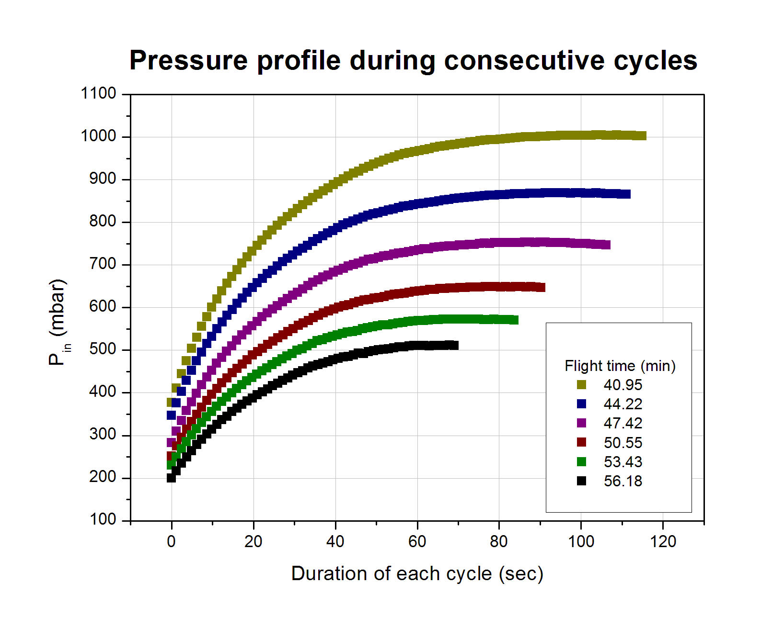

Graph 1: Pressure profile during stage 1 for different cycles

The following graphs are presenting the regression fittings for three of the sample cycles, using the aforementioned function, with the flight time of the initial conditions written in the title. The x axis shows the duration of each cycle in seconds.

Graph 2: Pin modeling during stage 1 with different initial conditions

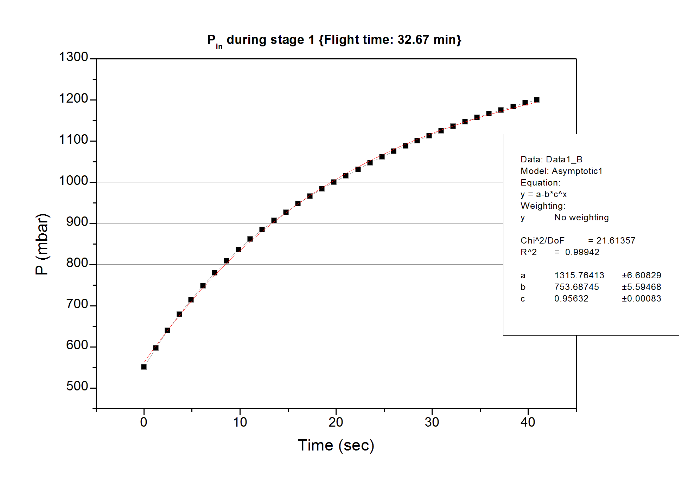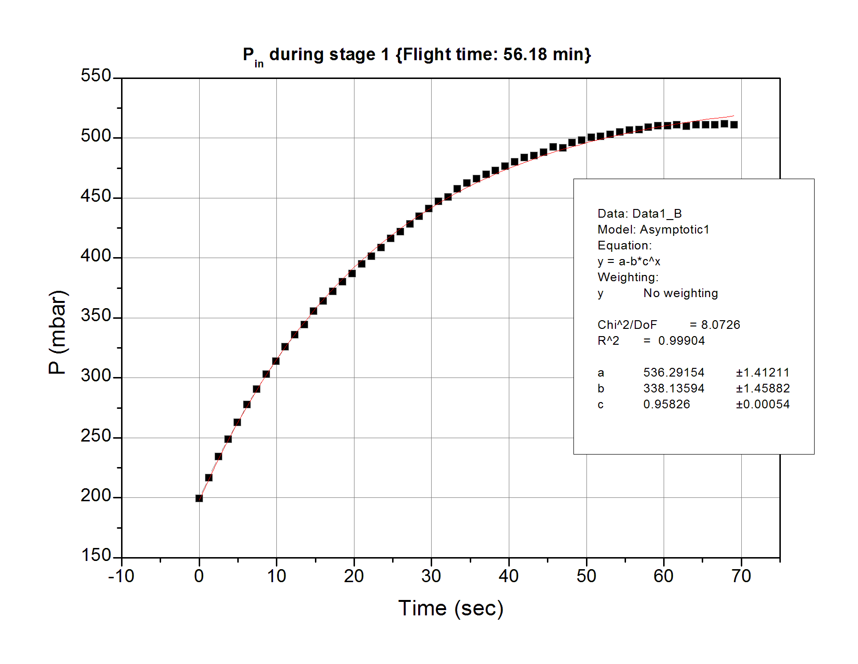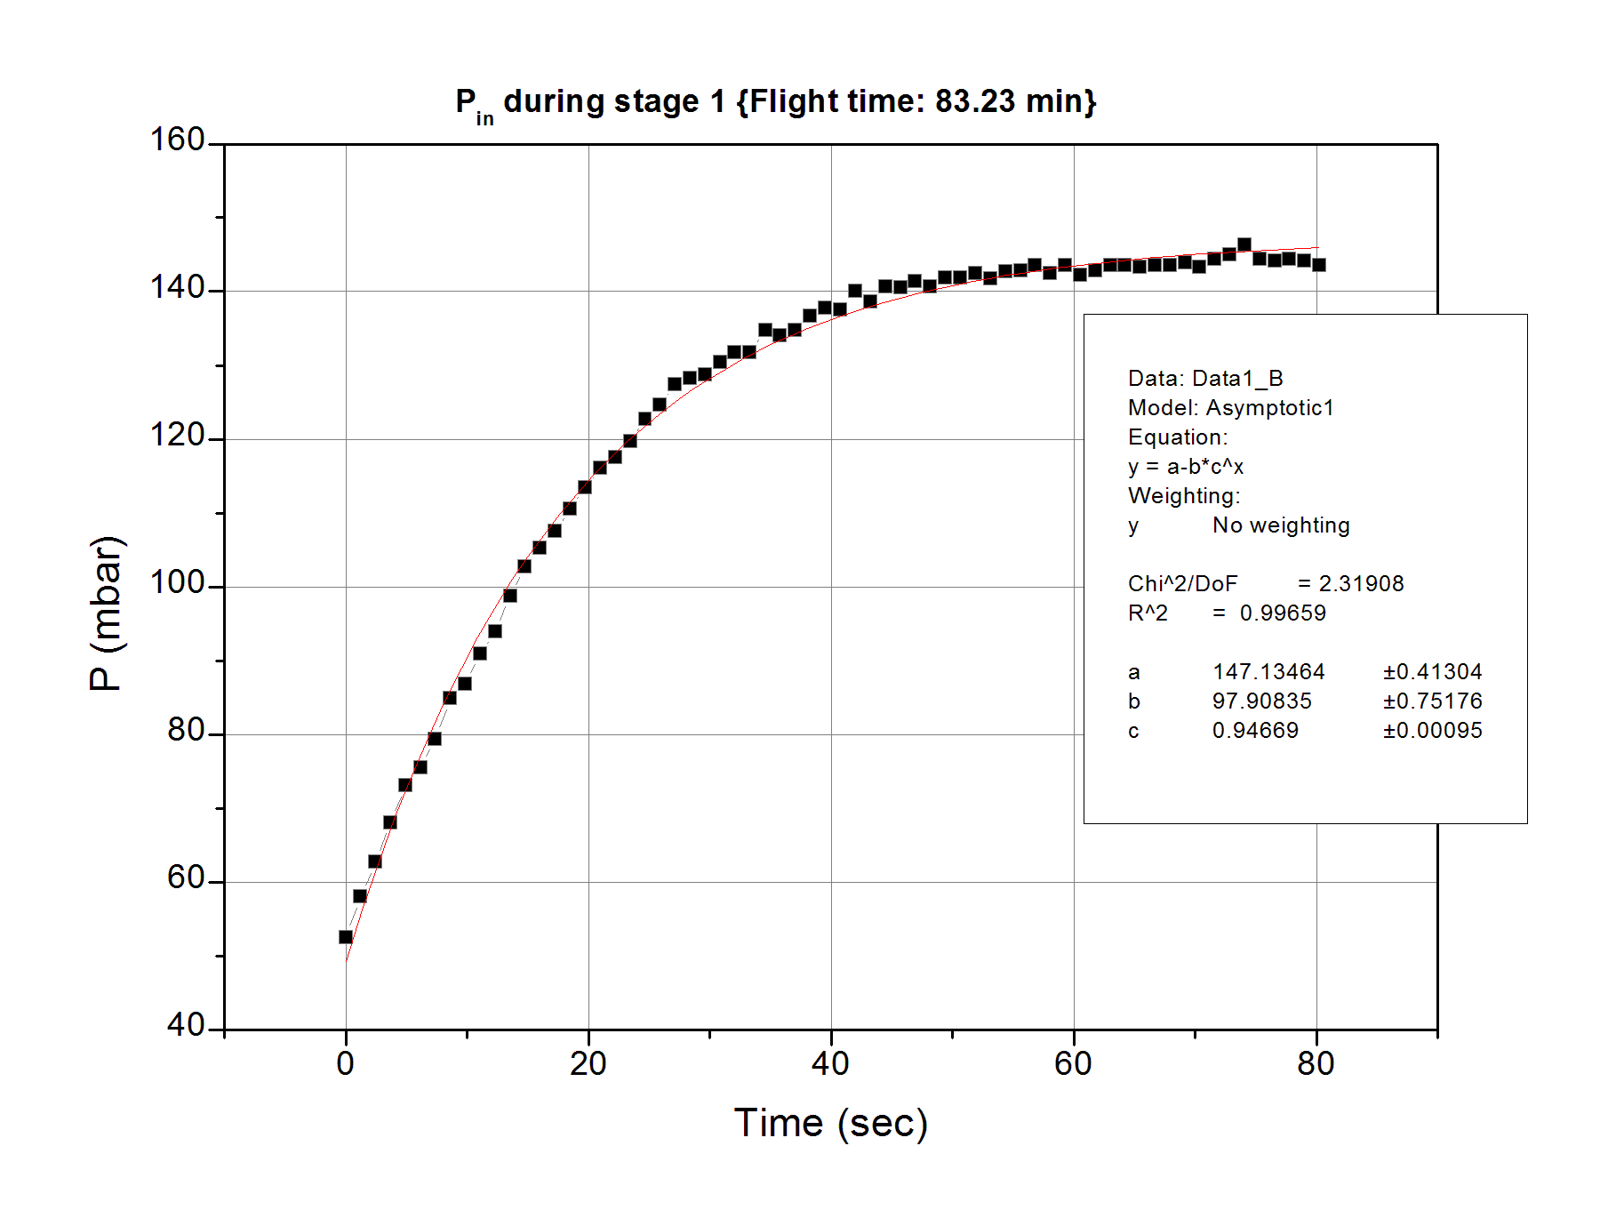

The parameters a, b and c for all the sample cycles are presented in the following table.

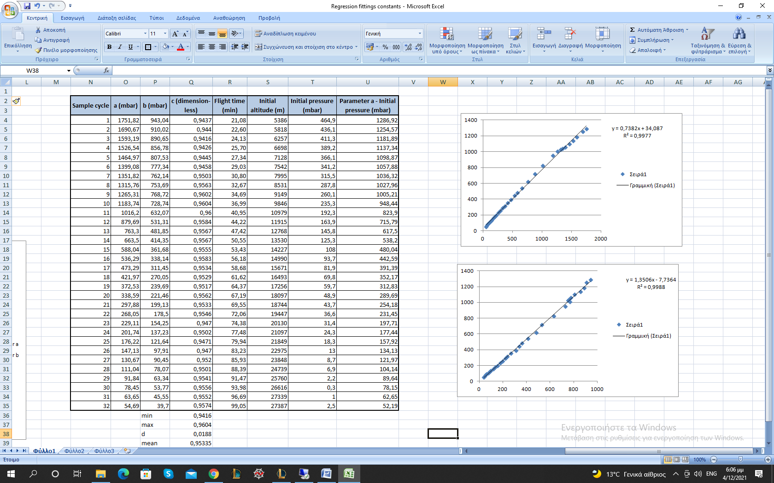

Table 1: Table of parameters and important quantities

In the first columns there are: the number of the sample cycle, the parameters a, b and c and the flight time. In the last columns there are: the initial conditions and the parameter a subtracted by the corresponding initial pressure.

There are some significant results that can be derived by examining this table. First of all, the parameter c is almost constant throughout the different cycles. The mean value of c, which is dimensionless, is:

while the maximum and the minimum c values are:

Thus, the maximum deviation from the mean value is 1.23% and hence it is acceptable to take c as constant, equal to the mean value of c.

The fact that this parameter remains constant is implying that there is no dependence on neither the initial parameters, nor the pressure difference (ΔP = P initial ambient – Pin). Thus, this quantity is characterizing the pump’s behavior. The pump will start pressurizing the air into the sensorbox, but after a relatively long time the pressure inside will tend asymptotically to the value of parameter a, since:

The other two parameters, a and b, are constantly increasing with the initial ambient temperature.

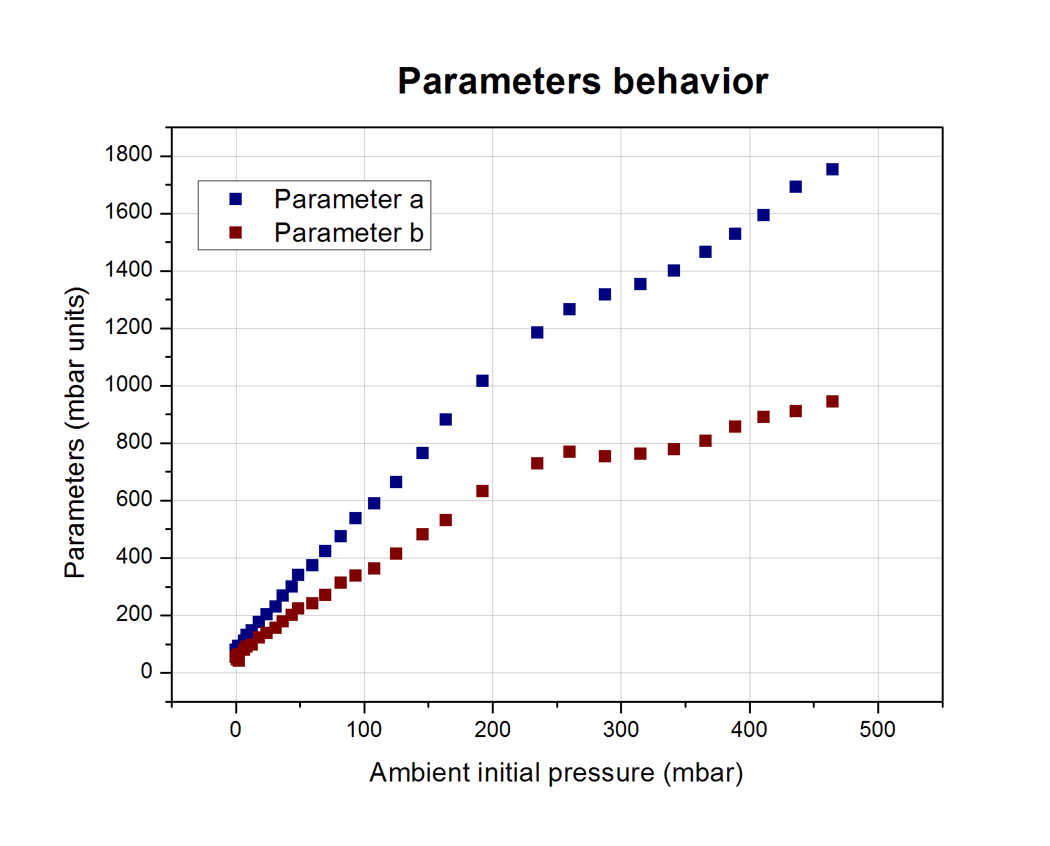

Graph 3: Parameters a and b

These two parameters are not dimensionless, but their units are millibars [mbar]. From their behavior it is clear that they strongly depend on the initial parameters, and especially on the ambient pressure. Yet, there is not an explicit relation between them.

By the form of the regression function, it is clear that the parameter a shows the maximum pressure that can be reached for a specific ambient pressure value. By subtracting the ambient pressure from the value of a, the pressure difference ΔP described above is formed, for the maximum Pin.

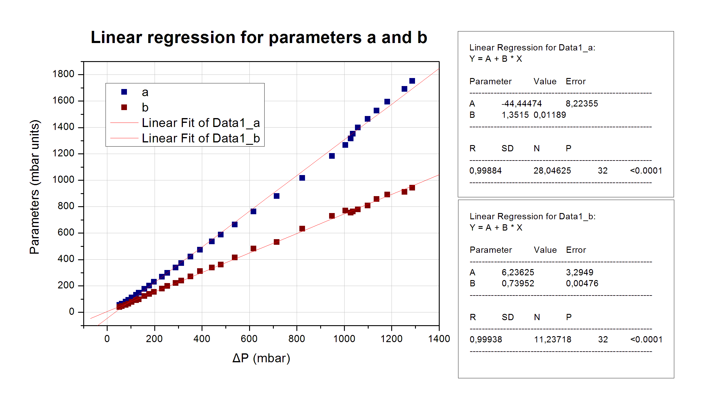

Graph 4: Parameters relation to ΔP

The parameters’ relation to ΔP can be safely regarded as linear in a first order approximation. Thus, both the maximum pressure that can be achieved by the pump and the parameter b are increased linearly with ΔP.

One more significant result can be derived from the pressure regression function. According to the experiment’s performance requirements, the pressure inside the sensorbox should be at least 800 mbar at the end of the pressurization stage. The function shows explicitly if the pump is capable of pressurizing the air over that target value, provided that it works for sufficiently long time. The only condition is:

The following plot shows the behavior of the parameter a over altitude. The requirement’s condition implies that the only acceptable region of this graph is the upper left. Hence, this requirement had been met up to 12.5 km or equivalently, for the first 40 minutes of the flight.

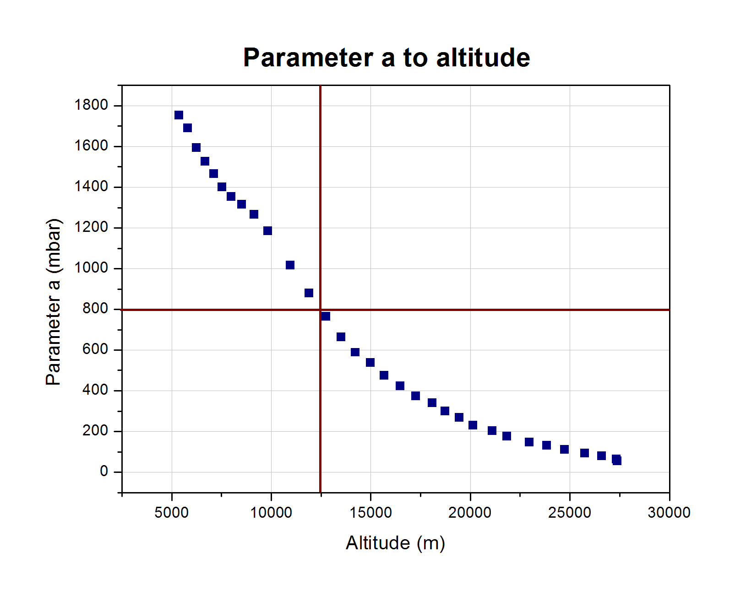

Graph 6: Performance requirement condition (acceptable region: upper left)

A more detailed examination of the pressure could provide more explicit information for their relation with the initial conditions. Yet, more details are not important for the experiment and will not be examined. What is important is that they depend on the initial conditions, regardless the closed form of the relation. Therefore, the regression function can be written as:

where this dependence is being implied with the symbol of the pressure generally.

## Conclusion

Returning to the formula:

and taking all the above into consideration, the flow-rate function can be written as:

or

or

It is explicit that the pump’s flow-rate function tends to zero. Hence, only if the initial conditions are favorable, the pump is able to pressurize the air sufficiently for the experiment’s needs. Considering the ambient conditions and the “**Performance requirement condition”** graph, this pump was not the correct choice for the whole flight of this experiment. An additional performance requirement is that the pump should provide a flow-rate of 3-8 L/min. It has been clear that the flow-rate always tends to zero, thus, in every cycle this performance requirement is not being met. Yet, taking the pump’s behavior into account, this requirement cannot characterize the efficiency of the whole experiment, since the pump could pressurize the air sufficiently up to 12.5 km.

# Centre of mass

In the chapter 7.1.1 “Calculating the centre of mass” the altitude in which single gas measurements of a cycle can be placed is calculated. This is called centre of mass, regarding this experiment, and is equivalent with the centre of mass of the air sample collected during one cycle.

In the abovementioned chapter the following formula has been derived:

where h0 is the experiment’s altitude at the start of a new cycle and h(t) is the experiment’s altitude at the moment t. From the chapter “Environmental and Experiment’s conditions” it is clear that the ascending phase was linear with a mean value of υ = 4.7 m/sec, thus:

Furthermore, from the chapter “Pump modeling” the flow-rate function Π(t) has been expressed as:

where d is a constant depending on the cycle number, and c =0.95335. With that being said, the center of mass can be expressed as:

where T is the duration of the corresponding cycle. By solving the integrals, hcm is calculated:

The above result is very important because it is independent of the corresponding cycle’s number.

By implementing this formula to the real altitude data for each cycle during the ascending phase, the following graph is generated. This graph demonstrates the point of measurement that is equivalent to the center of mass of the sample gathered during one cycle. Every gas measurement that will be presented will refer to the altitude of the center of mass of the corresponding cycle. The negative and positive error bars show the starting and the ending point of each pressurization stage, correspondingly.

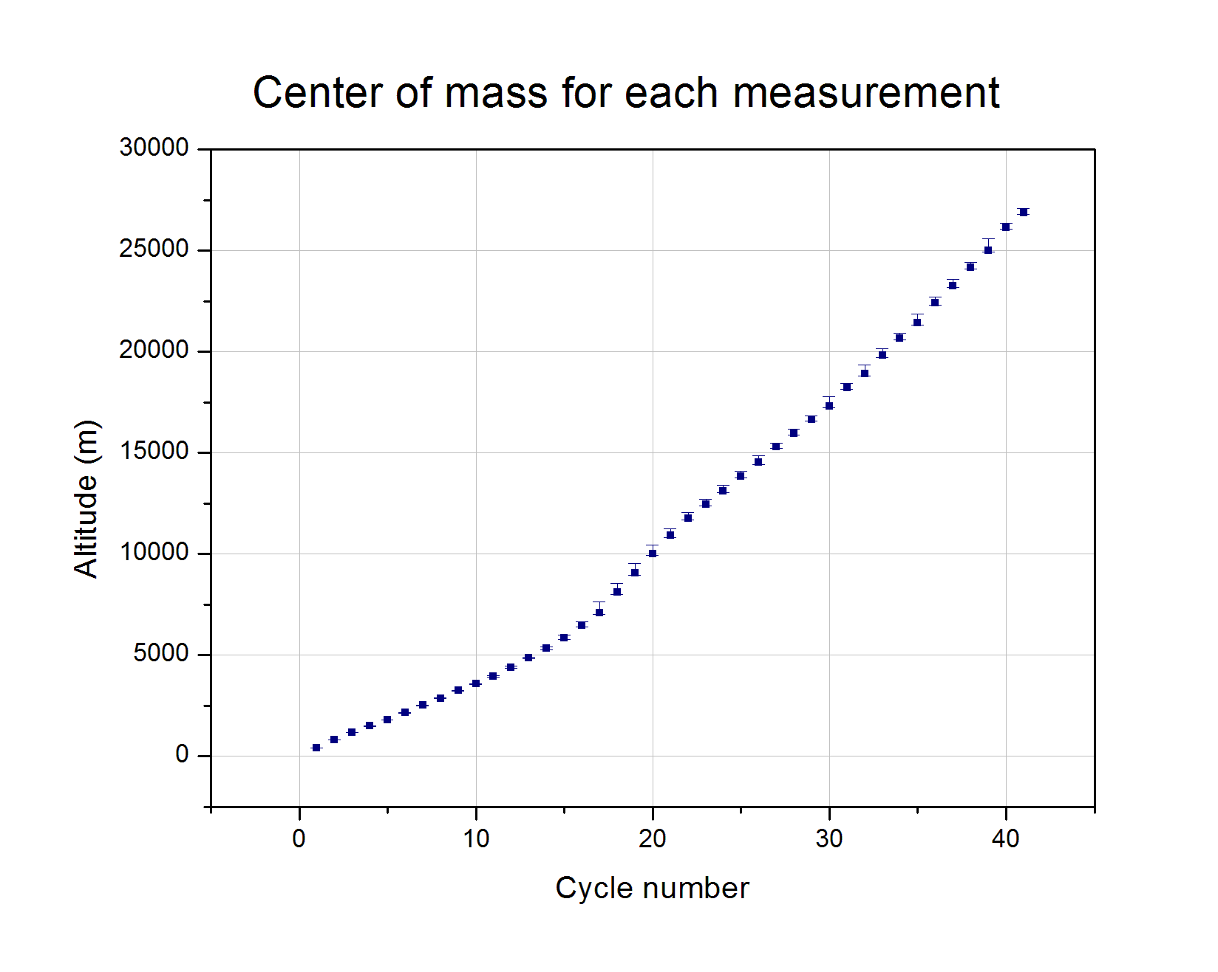

Graph 1: Altitude measurements of each cycle

In order to clarify the use of the center of mass formula, the following graph is presented, which is generated by the altitude residuals to focus on the error bars’ scale.

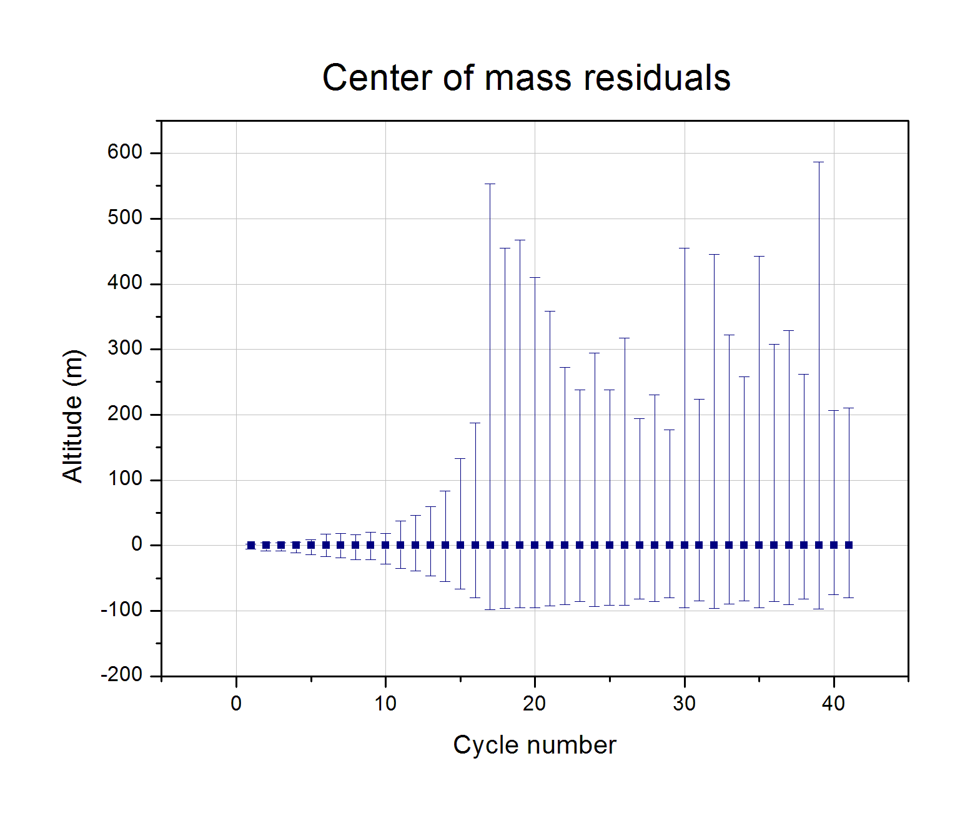

Graph 2: Error bars scale

From this graph it is being clear that estimating the center of mass is important, since there are cycles that lasted about three minutes, during which time the experiment’s altitude has changed significantly. The error margins range from some meters to almost 700 m. If symmetric error bars had been assumed, it would mean that the pump’s flow-rate was constant, which is completely wrong. The center of mass is shifted to lower values than the mean altitude of each pressurization stage, which is consistent with the observational data.

# Concentrations

## Introduction

Originally, the main target of the ECO-WISE team was to perform concentration measurements for Carbon Dioxide (CO2) and Ozone (O3) throughout the flight and thus build a profile for these two substances starting from the ground and reaching to early stratospheric altitudes. For that purpose, a pair of Infrared Gas Sensors (IR11BD) and a pair of Oxidizing Gas Sensors (OX-BX431) were used. However, these components are normally meant to operate on ground level and not on environments with constantly decreasing operating pressure and temperature. So, a structure which would suck, pressurize, and heat air to the desired amounts through a pump had to be built to artificially produce the suitable conditions. Unfortunately, due to a pressure leak and, as was explained in the previous segments, a wrongful pump choice the sensorbox was not sufficiently pressurized during most of its measurement cycles and as a result the validity of the concentrations given by the sensors at best cannot be ensured and at worst is entirely false. Additionally, no calibration procedures took place and thus the measurements cannot be used to produce a quantitative profile as was intended. Instead, an attempt was made to create a qualitative image for the gases. Each pair of sensors had different operating requirements and calculating sequences. A summary of those as well as a short presentation of the final findings is shown in the following paragraphs.

## OX-B431 (O3 Sensor)

### Environmental Performance Ranges

The sensor’s technical specifications manual indicates the pressure, temperature, and humidity ranges needed for its proper function. These three environmental variables were continuously monitored inside and outside the sensorbox and a thorough examination was completed in the Environmental and Experiment conditions segment. Firstly, the relative humidity inside the sensorbox was within 15-85 % only for the duration of the first few cycles. Afterwards, as can be seen in the graph below, RH% was always clearly below 15% during the measurement phase of each cycle.



Graph 1: Humidity Inside and Outside the Sensorbox as measured by ECO-WISE

Moreover, OX-B431 has an 800-1200 mbar functional pressure range. As was discussed in a previous section, such pressure was only achieved for about the first 40 minutes of flight, when the ambient pressure was greater than 280 mbar.



Graph 2: As can clearly be seen in the above graph, the inside pressure was not sufficient for a great part of the flight

Conversely, the temperature inside the sensorbox remained remarkably stable between 24 oC and 30 oC as has been previously shown. This temperature stability not only ensures that the sensors were inside their operating range, but it made the temperature compensation much simpler. Conclusively, for most of their operating phase, the two electrochemical sensors did not function inside their desired environmental ranges and their findings cannot be deemed reliable. Another possible, but not necessarily correct, way to interpret this result is that a great increase in the error margins for the measurements must be added.

### Calibration Procedure

An integral part of converting the voltage measurements (Working Electrode and Auxilliary Electrode) given by the sensors into O3 concentration is the proper and multi-layered calibration procedure. There are 2 main sets of currents which must be accounted for and measured separately in a known concentration environment. The first is a DC Voltage offset (the terms voltage and current are used interchangeably) on the electronics of the sensor which remains practically unchanged. Typical values are given for this offset by the manufacturer, but more accurate calculations are made during the calibration. The second set of currents is entirely due to the sensors and must be measured separately during the calibration as it is not stable at all. Due to the very low concentration of ozone in the atmosphere the measurements are comparable to these offsets and noise currents and thus it is impossible to make accurate measurements without having proper knowledge of them. Another important factor which must be considered during the final calculations is the temperature compensation. In this case, due to the stability of the temperature in the sensorbox, one multiplication factor given by the manufacturer is enough to produce acceptable results.

### Necessary Functional Approximations and Oversights with smaller contributions

Regardless of the calibration procedure approximations that unavoidably had to been made, there are two main initial assumptions under which the O3 concentration measurements are made. The first is the fact that the OX-B431 sensor measures the NO2 and O3 concentrations combined. Considering that NO2 appears in much smaller quantities than O3 and mostly in the lower levels of the atmosphere (due to its connection to human pollution) its contribution to the sensors’ output can be ignored ( small increase in the uncertainty of the measurements). The second approximation which negatively affects the validity of the given results is the algorithm used to convert the voltage readings given by the sensors to concentration. The application notes provide multiple methods to compensate for the existing background currents and the temperature in order to calculate the O3 concentration. Given the ozone’s small concentration, the measurements are a lot of times comparable to the background currents and thus there exists the possibility that the used algorithm greatly overcompensates. A somewhat better algorithm selection could have perhaps been made if the sensors had been calibrated but the issue would be persistent regardless. For the graph presented below the following algorithm was used instead of the one mentioned in chapter 8.9.



Where WEC is the corrected value for the working electrode and is converted to concentration. k’T is a constant which is temperature dependent for which only one value was used since temperature inside the sensorbox was stable. The other variables have been previously specified.

### Results

Considering all the above, the circumstances of the experiment clearly have made it so that meaningful and accurate concentration measurements cannot be reliably made from the sensors.

For the duration of the measurement phase of each cycle, the concentration measurements from both sensors are averaged and one measurement for each cycle is produced. This measurement is attributed to the altitude calculated by the center-of-mass formula. The following graph shows a qualitative image of O3 concentration (in arbitrary units).

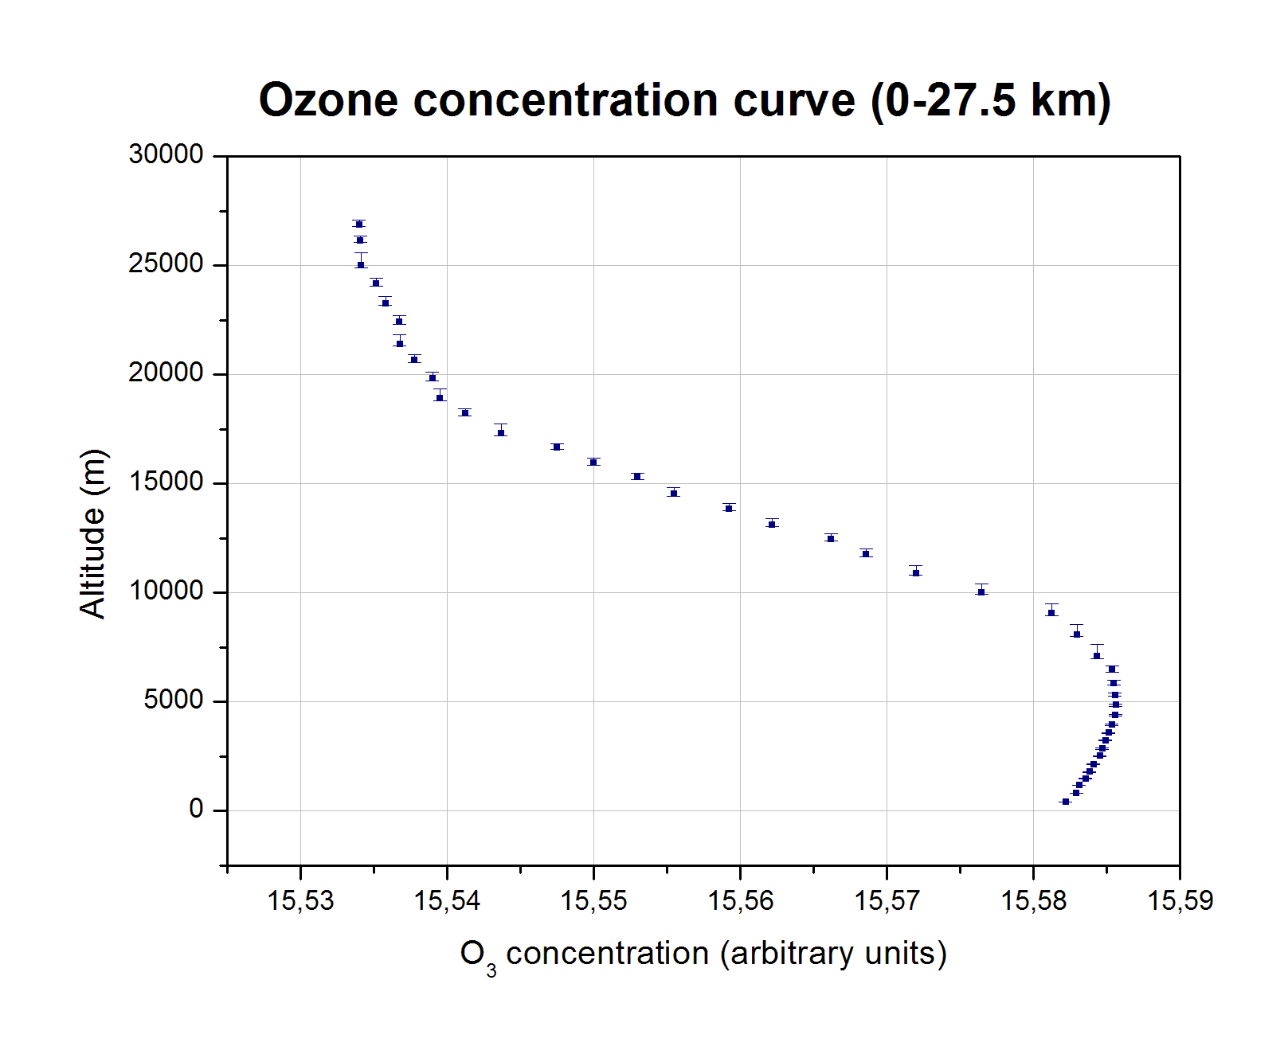

Graph 3: Characteristic concentration curve up to stratospheric Altitudes

As can be seen in the above graph, the density of measurements is noticeably greater in earlier heights. This is attributed to the pump’s function as explained in previous segments. No error bars were included for the horizontal axis (concentration value) considering that the units of measurement are arbitrary.

Another observation worthy of mention is that the derived curve has a smooth profile. This means that there are no outlier values which deviate greatly from the measured values around them. Thus, the hypothesis that the qualitative image produced is somewhat correct could possibly been made.

## IR11BD (CO2 SENSOR)

### Environmental Performance Ranges

Just like the ozone sensor, IR11BD has its own designated set of environmental variables which must be in a certain range. Specifically, as is expected, the sensorbox temperature was well within the specified range of -20 oC to 55 oC. Again, the relative stability of the temperature makes the calculations easier. The Relative Humidity range indicated by the sensor’s data sheet is 0%-95% so the sensorbox was obviously met the requirements. In the case of pressure, however, the minimum pressure needed for the sensor’s proper function is 300 mbar. Thus, the pump was only able to create acceptable conditions for the sensor during the first hour of flight or up to altitude with ambient pressure about 100 mbar as can be seen in the Sensor Box Variables graph. The measurements taken beyond that point cannot be considered accurate or even valid.

### Calibration Procedure

In the case of IR11BD, due to the higher concentration of CO2 in the atmosphere and the nature of the sensor, the calibration procedure is easier, less complex and produces better accuracy than the ozone sensor. In this case, there exist a few secondary constants that must be calculated through calibration, but they remain generally stable, so the manufacturer has provided a list of typical values. The main issue caused by not calibrating the sensor arises from the two main constants that need to be calculated separately for every sensor: the Zero and the Span. Essentially, *(the temperature compensation is omitted in this explanation because in this case the contribution is both minimal and easy to calculate thanks to the temperature stability)* the relation between the voltage measurements given by the sensor (denoted x in the equation below), the two constants and the concentration is:

Where n, a are two of the secondary constants and C is the concentration. In the two pictures below, it can clearly be seen that the concentration is extremely sensitive to small changes of Zero and Span. x is always greater than 0 and less than 0.3 in the taken measurements, two typical values are taken for n and a. These pictures are two families of concentration functions for different values of Zero and Span respectively

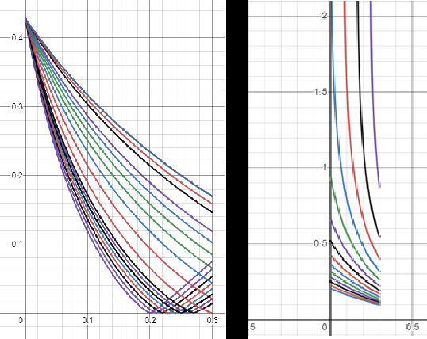

Figure 1: A family of concentration functions for small changes to Zero and Span respectively

As can be seen in the graph above, for very small changes in Zero, the shape (monotonicity and curvature) of the function can change. The minimum of the function changes position. Likewise, for small changes in Span, a great change in scale can be observed.

### Results

Unfortunately, it can be safely determined that a reliable quantitative depiction of carbon dioxide concentration in the atmosphere is certainly not feasible without proper knowledge of Zero and Span. Additionally, the qualitative image shown below (*which is derived using the same method mentioned in the ozone section)* comes with great uncertainty.

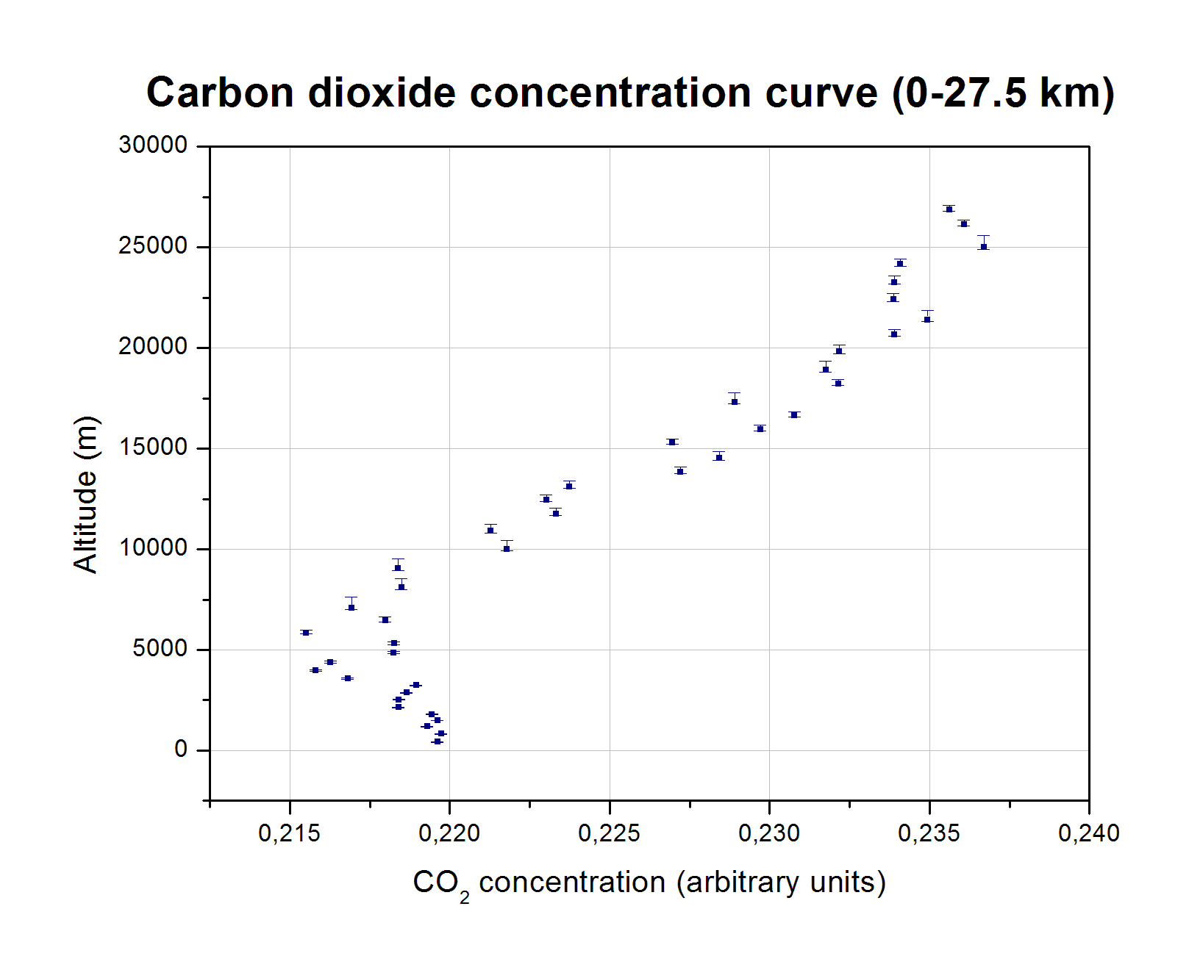

Graph 4: CO2 Concentration curve up to early stratospheric altitudes

As is clear from the presented graph, the same observation about measurement density can be made (that is expected, both sensors were in the same sensorbox). However, the same things cannot be said about the smoothness of the characteristic curve. Again, the measurements tend to follow a specified curve and are not completely random but, in this case, there are obvious gaps and noticeable deviations from the curve.